**REFLECTION OF INDONESIAN HORROR STORIES IN STUDENTS’ WRITING**

**Ratmiati1, Muspardi Muspardi 2, Mita Domi Fella Henanggil3, Sri Antoni4**

Fakultas Tarbiyah dan Ilmu Keguruan, UIN Mahmud Yunus Batusangkar 1,2

Fakultas Bahasa dan Seni, Universitas Negeri Padang 3

SMK 3 Teluk Kuantan 4

email: ratmiati@uinmybatusangkar.ac.id

DOI: prefix/singkatan jurnal.volume.nomor.nomor artikel

|  |  |  |
| --- | --- | --- |
| **Article info** | | ***Abstract*** |
| **Article History**  **Recieved:**  Tgl/Bln/Thn  **Accepted:**  Tgl/Bln/Thn  **Published:**  Tgl/Bln/Thn  🖂  Corresponding author | *This research explains the reflection of horror or mystery stories of Indonesia in students' writing. Horror stories, ghosts, and various other mystery stories currently in Indonesia are becoming trending topics. Not only adults who flock to find out, but also children who are still in school. This case can have an effect on psychology, attitudes, and abilities of students. one of which is in writing stories at school. This type of research is quantitative research. Data collection is used by using a test writing story skill instrument that contain mystery and also by conducting interviews with students about their enthusiasm to know, listen to, and watch horror films in their daily lives. The object of this research is 31 students. The results of this study indicate that there is an influence of the horror stories and mysteries they witnessed on television on students' story writing skills at school. This is evidenced by the results of 55% of 31 students writing horror stories that are generally related to horror stories including being filmed in Indonesia and 45% of students writing ordinary stories. This research is useful for teachers in helping students to improve their imagination*  ***Keywords:*** *horror stories; writing; students; reflection* | |
| *Lisensi Creative CommonsJIES is licensed under a Creative Commons Atribution-Share Alike 4.0 Internasional Licence* | | |

**INTRODUCTION**

In general, students can start writing activities with things that are close to them (Soleh & Siti Afriani, 2016)about their families (Subekti, 2022) which can represent the situation around them (Hasan, 2022). The ability to write is influenced by concern for the social environment, the phenomena that occur, and the phenomenon that impresses them (Rohman & Jurusan Pgmi Fakultas Tarbiyah, n.d.). Even stories written by students can also come from ideas in the film (Arifian, 2017). Various stories from the stories raised in the films, can be through short videos, etc (Pratt, 2015). As a result of the many appearances of ghost films and stories that there are people often questioned when the story of the ghost movie begins (Middleton, 2015) a Western philosopher mentioned the existence of these horror stories starting from 25 years ago.

Some people must have their own genre related to their favorite films. But one of the most popular genres is a horror film. Therefore it is not surprising that many horror films are produced every year.

Apart from the horror stories that have been discussed, the story has an impact on many people. Especially children who have just developed the world of imagination. One of the activities that helps students explore about him is writing activities carried out at school. Writing and writing again is an important key in achieving a proficiency in these language skills. but it also needs to be realized, that writing is not just composing words and paying attention to the sentence structure, but also paying attention to the essence of the story to be written in the story (Cushman, 2015); par(Parr & Stevenson, 2014)

The effects of this horror story vary. Some scientists believe that witnessing things that smell of horror is not always a negative impact, but on the contrary, it can even increase enthusiasm. This is what encourages the desire of some film productions to flock to create films that are attracted by peoners. On the other hand, the wider community disagrees with the ideas of some of these scientists, they even consider horror films, horror stories will only have a negative impact on the child spikologis (Clasen, 2017) and only highlight sensuality alone (Benson-Allott, 2015). Ghosts are limited to mere ideological services which have no effect (Mubarki, 2014)

Likewise in Indonesia, the Indonesian cinema world entered a new era in the early 2000s. This was marked by the increasing number of film production per year after the Indonesian film industry had previously been suspended. Along with the development of trends, genres, and world film technology, national films are increasingly varied. This has resulted in the emergence of national films with different genres and market segments.

Film is one of the media to convey a very powerful message (Wilson et al., 2014). Film is a communication media that is audio visual in nature to convey a message to a group of people who gather in a certain place. An example is the American horror film that conveys the message of feminism through story after story in. Movie messages on mass communication can take any shape depending on the film's mission (Clasen, 2017); (Wilson et al., 2014)

In writing requires inspiration, inspiration comes from anywhere. In the context of this research inspiration can come from horror films, ghosts and mysteries because stories of horror stories will generally describe the visual culture that exists in humans (Brinkema, 2015). Generally a film can include a varietyof messages, both messages of education, entertainment and information (Steinmetz, 2017). The message in the film is to use the mechanism of symbols that exist in the human mind in the form of the contents of messages, sounds, words, conversations and so on. Therefore, this study aims to examine the effect of these horror stories on the ability to write student stories in school.

**METHODS**

This type of research is descriptive qualitative, descriptive research. Descriptive research is research that attempts to describe a symptom, event, event that is happening at the moment. Descriptive research is a type of qualitative research that has a descriptive nature and tends to use analysis. Process and meaning are emphasized more in this type of research with a theoretical basis that is used as a guide so that the research focus is in accordance with the facts in the field Ramadhan (2021:6). The research data was obtained from the results of the final test of story writing skills by students in one of the schools in Bandung. The final test results of students' story writing skills were analyzed using statistical formulas.

The population in this study were students in Bandung, amounting to 56 people divided into 2 classes. This study took a sample of 50% of the 56 student population with 31 students. Method should make readers be able to reproduce the experiment. Provide sufficient detail to allow the work to be reproduced. Methods already published should be indicated by a reference: only relevant modifications should be described. Do not repeat the details of established methods. The method section covers: Respondents, Instruments, Procedures, and Data analysis.

**RESULT AND DISUSSION**

**3.1 The Process of Getting Horror Stories as Science by Students**

Since the introduction of the new curriculum in 2013 until now, learning in schools in Indonesia today always begins with literacy activities. The activity of reading one book one day. This is a real example that the current reading movement in Indonesia is being demanded to literate literacy. Not only reading literature, but also other reading books, one of which is a reading book about ghosts (horror).

In several times learning the teacher presents horror books that can be read by students. of course the books are worth reading by students at their teens. Based on several treatments and several observations carried out by researchers and collaborations with subject teachers, there are a number of important things to discuss in this chapter. among them is reading, watching movies, even told by the teacher is a way for students to gain knowledge about horror films and mystery stories. Even though after being interviewed the experience and knowledge of the horror story was mostly obtained from the process of watching at home. For example through television, youtube, and telephone applications that provide access to get that information.

In the learning process of writing story texts, the teacher gives instructions several times to write the most memorable stories for them, either fiction or stories based on their

own experiences. In learning takes place, students are not asked by the teacher directly to write stories about ghosts or mysteries, but students are free to write the text of the story they want to write. While the story is memorable and interesting for them.

From the process of writing activities, 31 student works were collected. the interesting thing about these students works is that 54% of students from 31 students overall wrote ghost stories, mysteries and horror. The various titles they make, but overall the story made is a story with a genre of ghosts, mysteries, and horror. Below are several student works whose content is consistent with ghost stories that have been filmed in Indonesia.

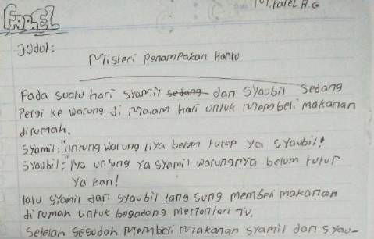

**Figure 1 The Mystery of Ghost Sightings**

In figure 1, students tell about the mystery of ghost appearances in an empty shop at night. Syamil and Syaubi intend to buy food at the stall. in the middle of the night the shop had not yet closed. Syaumil is grateful that he can still buy food, and so is Syaubi. Syamil suddenly felt something strange after buying food, the food they bought had become a lump of dirt and the stall that was still open suddenly turned into a dark and scary stall. they also saw that the shopkeeper was not like an ordinary human, but like a very scary ghost. They ran fast and left the shop because they were afraid of a ghost apparition.

The story written by this student is almost the same as the horror film that was once phenomenal in Indonesia, namely the film Perempuan Tanah Jahannam, directed by Joko Anwar. It is said that two friends came to a remote village with the intention of getting an inheritance. Unexpectedly, the village where their parents came from turned out to be cursed. These residents believe that to remove the curse, someone must be sacrificed. And the person who had to be sacrificed turned out to be Maya, a character who was after her inheritance.

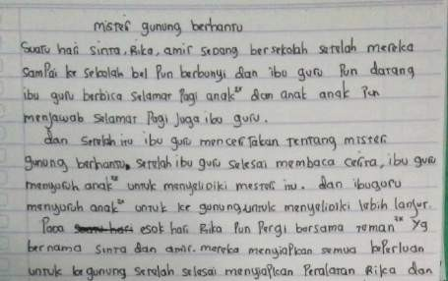



**Figure 2: The Mystery of The Ghost Mountain**

In figure 2, the student told in his work about the mystery of the ghost mountain. This story tells the story of three elementary school students who listen to the teacher tell a story about the mystery of the ghost mountain. After telling that, the teacher asked the students to investigate the mystery whether it really happened or not. The students write their story about a mountain inhabited by ghosts. The beginning of this story is from the teacher who tells the story of haunted mountain mysteries, then comes the curious character of the storyteller who wants to investigate whether it is true that the mountain told by their teacher does have a ghost. Therefore, they agreed to investigate it. Such is the story written by students about the Mystery of the Haunted Mountain.

This story has a similar story to the ghost film on Indonesian television for examples Pasar Setan in 2024. Diproduksi oleh IDN Pictures, film ini membawa penonton pada perjalanan misterius yang belum pernah terjadi sebelumnya, dengan setting yang menyeramkan di gunung. The story begins with Rani's move from Jakarta to Banyuwangi, after being transferred due to a surprising incident of wrongful arrest. However, adapting to the new place does not go smoothly, especially when he finds that the office leader underestimates his abilities, making it even more difficult for him to adjust. One day, Rani accidentally discovered a murder case involving a female vlogger named Tamara. But to her surprise, Rani realized that the case had covered the office where she worked. Not accepting such a situation, Rani decided not to remain silent and promised to reveal the truth behind the case.

The two works share stories with ghost stories that have been filmed in Indonesia and had also become trending topics in Indonesian society. Namely the film: Rumah Hantu released in 2017 by Tripler Film. The film tells the story of five young men who went to a village and lived in a house that had been abandoned by the owner for a long time. Genesis after strange events began to be felt by this young man so they were curious about what really happened in the house in the past. The story of the ghost ended with the unfolding of the story of the haunted house trying to be dismantled by the five young men.

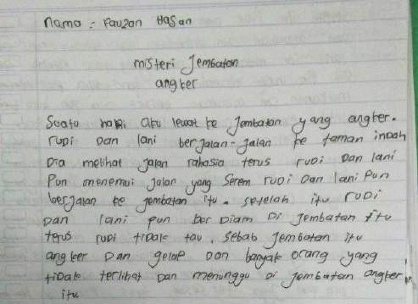

**Figure 3 about The Mystery of The Armed Bridge**

Figure 3, students wrote about a bridge inhabited by a ghost that is very scary. Students wrote a series of stories very well and clear story segments from beginning to end. This story is almost similar to ghost stories that have been aired on Indonesian television.

Based on figures 1 and 3, students wrote stories that are almost the same as ghost stories that have been aired on Indonesian television. Figure 1 discusses the mystery of ghost sightings involving Syamil and Shabil figures in an empty shop. This is in accordance with the ghost story that was aired on an Indonesian television station entitled "Misteri Gudang Kosong".

Some people must have their own genre related to their favorite films. But one of the most popular genres in Indonesia is a horror film. Therefore it is not surprising that many horror films are produced every year. The ghost films produced can also be watched by children through YouTube freely. Anyone can access it for free, they will enjoy ghost stories from beginning to end. Here are the most popular ghost films in the world of Indonesian cinema from 2018 to 2019.

One of the Indonesian language learning in schools is learning writing essays. Students will be asked by the teacher to write an essay which they think is interesting in terms of the story. In learning to write the essay, the teacher asks students to write essays for 90 minutes (during the learning process). During the writing process, the teacher observes students who are writing essays. After writing the teacher collects essays and evaluates them. After an assessment, the teacher finds a different thing. That most of the students' essays tell about ghosts or mysteries. The ghost story told in the essay has the same story with ghost stories that have been aired on Indonesian television. This is the background of the researchers to conduct research on ghost stories contained in students' essays.

Next is the percentage of students who choose ghost stories to tell in their writing learning. From the data obtained in the field, there were 17 students from 31 students making their own ghost stories or mystery versions.

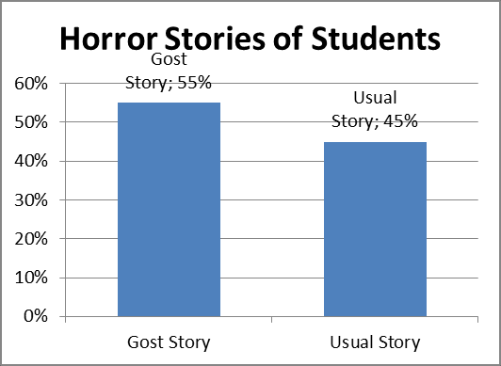

The 31 samples tested during the study there were two categories of stories made by students. 55% are stories about ghosts and mysteries which are generally influenced by ghost stories that have been filmed in Indonesia. The rest, as many as 45% of students write about the usual theme, for example about playing to the zoo, playing with friends, and also about going to Mecca.

**3.2 Interview with Student about their experience about gost story or Mystery Film**

As many as 31 students who were tested, there were 55% of students who made mystery stories. After the writing process is done, a question and answer session are conducted with students about their experiences about ghost stories, most of which have been written by students in their writing. The following are the results of interviews with several students.

Data 1:

"I've watched a ghost movie at home, I remember a story because it's scary.”

This student claimed to have watched a ghost movie at his home. He remembers the incident after the story of the film. This student also revealed that the film was hard to forget because the story was scary. Then, on the other hand, this student also stated:

Data 2:

"I really like watching horror films with my sister, so I wrote stories about ghosts and

mysteries.”

Students in data two, like watching ghost films with their own siblings. It turned out that for him and his friend was a scary thing so when asked to write a story by the teacher he preferred to make stories related to the mystery. In addition, there are also students who claim to like horror films because the contents of the story make it interesting. This is in accordance with the following statement.

Data 3

“I like it because the content is curious”

On the other hand, students also claimed to have watched a ghost movie to a movie because they were invited by their own brother, ghost stories tend to make him afraid, he would close his eyes if the ghost scene would be aired and would open his eyes again if there were no ghost scenes. It was exciting for himself because the ghost story was a good one. In accordance with the following data:

Data 4

"The ghost stories I've watched with my sister at the cinema made me scared but I want to watch it again because the story is good."

Researchers also found that watching a ghost movie had become a family routine on certain days. One of them is for the following students who stated that watching a ghost movie has become a family habit every Friday because it was intentionally aired by an Indonesian television in the afternoon.

Data 5

"After Friday prayers at home, we watch ghost films on television, which makes me not afraid to watch ghost films."

Data student 6 admitted that he was not afraid to watch a ghost movie because he watched the ghost story with his family together. And also watched during the day. The ghost film that is meant by this is "Suzzana", in Indonesia, a ghost movie is broadcast on one of the television stations during the day, precisely every Friday at 13.00 pm. This has become a routine for them to watch ghost genre films.

From these data, it can be interpreted that the reason students write ghost stories as the theme of the stories that will be written brands include

a. like to watch horror movies b. the film is interesting

c. the story is creepy and difficult to forget

d. the contents of the story that made me curious.

The results and discussion section can be divided into several subtopics. The presentation of results and discussions should provide a clear and precise description of the research findings, the author's interpretation of these findings, and the conclusions that can be drawn.

**CONCLUSION**

The conclusion of this study is that the existence of horror stories obtained by students through television, mass media, and stories obtained from the public influences the ability to write students' stories in qualifications 53-54%. Information about ghost stories and the experiences they get from watching movies, and also stories in the community have an influence on 61.3% qualifications on students' ability to write ghost stories. Based on this, it can be concluded that H1 is accepted, because there is a significant influence between horror stories and mysteries circulating among the public towards students' writing ability about ghost stories. This study is useful for Indonesian language subject teachers to consider the stories of ghosts circulating in the community, not always influencing workers to students' abilities. but also supports students in pouring out all imaginations that exist. The nature of the students will write stories that they think are memorable and not easily forgotten, one of which is the presence of ghost stories, mysteries, and horror circulating in the community.

**REFERENCES**

Arifian, F. D. (2017). Pendekatan PAIKEM sebagai solusi atas permasalahan pembelajaran bahasa Indonesia. *Jurnal Pendidikan Dan Kebudayaan Missio*, *9*(2), 148–160.

Benson-Allott. (2015). Dreadful Architecture: Zones of Horror in Alien and Lee Bontecou’s Wall Sculptures. . *. Journal of Visual Culture*.

Brinkema. (2015). Introduction: A genreless horror. *Journal of Visual Culture*.

Clasen. (2017). *Why Horror Seduces*. Oxford University Press.

Cushman. (2015). “Write Me a Better Story”: Writing Stories as a Diagnostic and Repair Practice for Automotive Technicians. *Journal of Technical Writing and Communication*.

Hasan. (2022). Penerapan Metode Field Trip dalam Menulis Puisi Siswa Kelas X. *Jurnal Inovasi, Evaluasi Dan Pengembangan Pembelajaran (JIEPP)*.

Middleton. (2015). Documentary Horror: The Transmodal Power of Indexical Violence. *Journal of Visual Culture*.

Mubarki, M. A. (2014). Mapping the Hindi Horror Genre: Ghosts in the Service of Ideology. *Mapping the Hindi Horror Genre: Ghosts in the Service of Ideology*.

Parr, H., & Stevenson. (2014). Sophie’s story: Writing missing journeys. *Cultural Geographies*.

Pratt, A. T. (2015). Horror and exploitation on VHS: The history of home video comes to Yale. *Journal of Visual Culture*.

Rohman, S., & Jurusan Pgmi Fakultas Tarbiyah, D. (n.d.). *MEMBANGUN BUDAYA MEMBACA PADA ANAK MELALUI PROGRAM GERAKAN LITERASI SEKOLAH*. *4*.

Soleh, K., & Siti Afriani. (2016). Teknik mind mapping sebagai upaya untuk meningkatkan keterampilan menulis cerpen pada siswa sma. *Jurnal Pendidikan Surya Edukasi* .

Steinmetz, K. F. (2017). Carceral horror: Punishment and control in Silent Hill. *Crime, Media, Culture*.

Subekti, M. A. (2022). KETERAMPILAN MENULIS CERITA PENDEK SISWA SMA. In *Maret* (Vol. 4, Issue 1).

Wilson, N., Deb Heath, Tim Heath, Peter Gallagher, & Mark Huthwaite. (2014). Madness at the movies: prioritised movies for self-directed learning by medical tudents. *Australasian Psychiatry*.